The Price of Gold (e-book) by Steve Cagan and Mary Kelsey

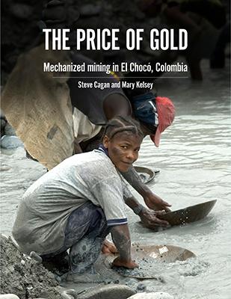

We’re pleased to let you know that The Price of Gold: Mechanized mining in El Chocó, Colombia, a culmination of years of work in the region, is available now as an e-book in both English and Spanish versions

The Price of Gold is a product of years of observation and inquiry around problems caused by modern mechanized gold mining in a Pacific rain forest area of Colombia, where environmental degradation and cultural upheaval have been the results. The book includes 96 pages of photographs, drawings and narrative, with testimonials from people in the area.

The book is available now from Amazon Kindle, for their devices and apps. It will shortly be available from Apple Books, and from Kobo and other sources. We have a table below of the current sources; we expect to update this information as more come online.

The e-books are selling for $3 USD. We expect them to be available to borrow from libraries very soon. We are eager to see the book used in classes and other activities, and by organizations in struggle. If you want to get copies from us for such use, please get in touch.

A book like this comes alive by being read. Please help by distributing this information to your networks. Thanks.

For The Price of Gold:

Agency | URL (of the book)
Amazon/Kindle  (for Kindle devices and apps) | https://www.amazon.com/dp/B08B1VSYKK
Apple (for Apple devices) | https://books.apple.com/us/book/id1518310377
Kobo (for the majority of devices and apps) | https://www.kobo.com/us/en/ebook/the-price-of-gold-mechanical-mining-in-el-choco-colombia
Angus & Robertson  (Australia) | https://www.angusrobertson.com.au/ebooks/the-price-of-gold-mechanical-mining-in-el-choc-colombia-steve-cagan-and-mary-kelsey/p/9780996607827
Vivlio  (France) | https://www.vivlio.fr/9780996607827_9780996607827_10020.html

